## Lab 6-01: Launching AWS Cost Explorer and AWS Budgets

### Lab Prerequisites

* Familiarity with basic AWS Cloud Computing concepts and terminology
* An AWS account with an active subscription

### Service Introduction

AWS Budgets allows you to create custom budgets that notify you if your cost or use exceeds or is expected to surpass your planned amount. It is a way of creating a budget for your AWS account and forecasting costs before they have been incurred.

AWS Cost Explorer is a user-friendly tool for visualizing, understanding, and managing your AWS expenditures over time. It is utilized to investigate costs after they have occurred.

### Case Study Enterprise Oil and Gas Contractor – Vector Energy

Background

Vector Energy is a specialty energy infrastructure contractor based in Houston, Texas, serving the oil, gas, refinery, petrochemical, and power industries. Engineering, procurement, construction, scheduled shutdowns, maintenance, facility development, and operations services are among the company's services. Vector Energy has constructed more than 114,000 miles of pipeline and employed more than 400 clients in 60 countries.

The oil and gas industry is cyclical. Vector Energy's capacity to adapt swiftly to new opportunities when there is high demand and scale back when demand is low is important to the company's success. The physical server infrastructure Vector Energy had in place was hampering the company’s marketplace agility.

The company’s IT environment combined collocation and on-premises servers in four primary data centers. Vector Energy also had dozens of offices—which sometimes had their servers and networks—spread across the United States and Canada. The IT staff could not respond swiftly to new project requests in this physically distributed environment. It had trouble calculating the capacity required for new projects and quickly provisioning the appropriate number of servers. Without the ability to scale, the IT department would often oversubscribe, purchasing 20% extra capacity to avoid running out.

In addition, Vector Energy leadership wanted to focus on developing its core business, not its IT infrastructure. So, the company decided to move its business applications to the Cloud to improve agility and focus more on developing its core business. AWS was the first choice for Vector Energy due to strong relationships and previous support experience.

Business Challenge

Vector Energy is planning to subscribe to many AWS Cloud services. The business development team needs to handle multiple AWS accounts where they manage every account's bills and budget by maintaining an excel sheet, monthly and yearly. They want to visualize the budget report using Excel. They hired you as a Cloud professional and asked you to provide a budget report with just one click for a monthly and yearly plan.

Proposed Solution

As a Cloud professional, you will use the AWS Cost Explorer to automate this task. With this, you can easily manage and maintain all AWS account budgets and costs within the organization and each account's metrics. It will start populating data immediately with one click, but it can take up to 24 hours to populate spending data for your AWS account.

Lab Diagram

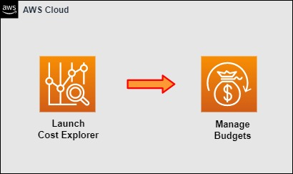

Figure 6-01: Lab Diagram

Implementation Steps

1. Launch the Cost Explorer.
2. Manage Budgets.

### Solution

|  |
| --- |
| **Step 1: Launch the Cost Explorer**   1. Log in to the **AWS Management Console**.      1. Click on **Billing Dashboard**.      1. Now, navigate to the **Billing & Cost Management** page. 2. On the **Billing & Cost Management** page, from the left side of the **Home** menu, click on **Cost Explorer**.      1. After clicking on **Cost Explorer**, click on **Launch Cost Explorer**. It will start your **Cost Explorer**.      1. Navigate to the **AWS Cost Management** page, where you can visualize and manage costs easily. 2. The **Home** page of the **Billing & Cost Management Dashboard** is now displayed.     **Step 2: Manage Budgets**   1. From the left side of the **Home** menu, click on **Budgets**.      1. On the **AWS Budgets** page, you can manage the costs and budgets of different accounts within your organization. |

## Lab 6-02: Creating Resource Groups

1. Log in to the “AWS Console”. Go to All Services and select “Resource Groups & Tag Editor” under Management & Governance”.

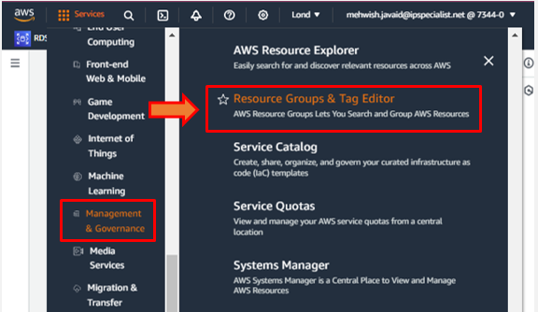

1. Click on “Create a resource group”.

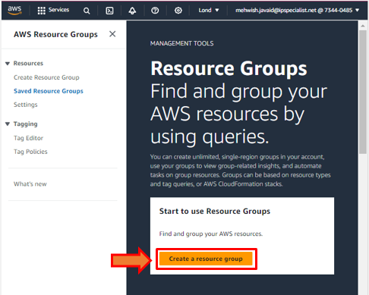

3. Choose “Tag based” group type to create resource group.

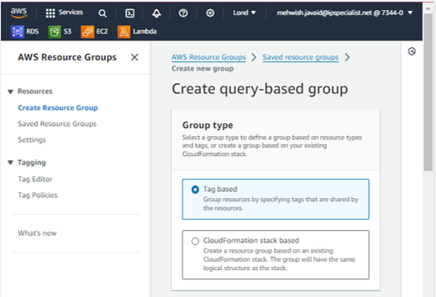

4. Enter “Group details” and “Group tags” according to your requirement.

5. Click on “Create group”.

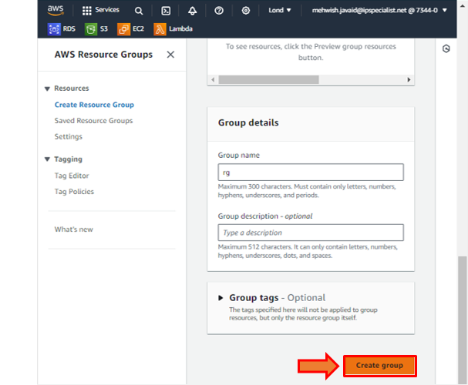

6. The notification of successful creation will appear.

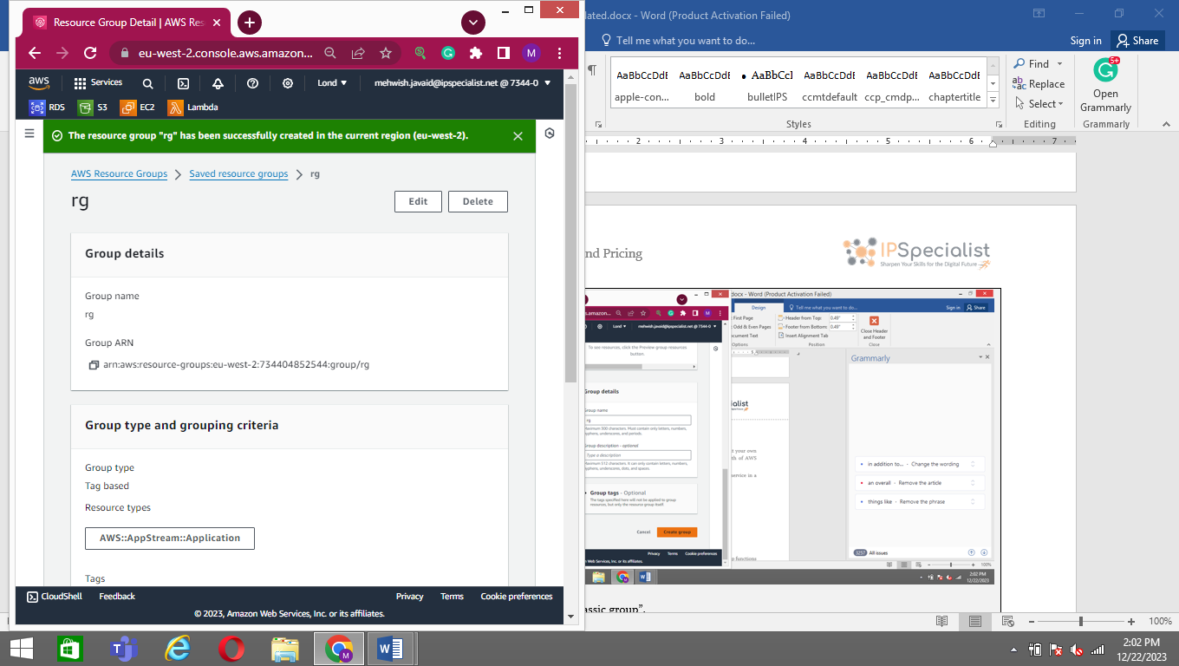

7. You can also visit the resource group homepage, displaying all the resources with the tags and values you requested.

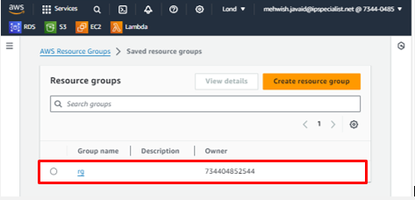

## Lab 6-03: Using Tag Editor

1. Log in to the “AWS Console” and click on “Resource Groups”.
2. Select “Tag Editor”. Enter all the required detail, including Regions, Resource types, tags.

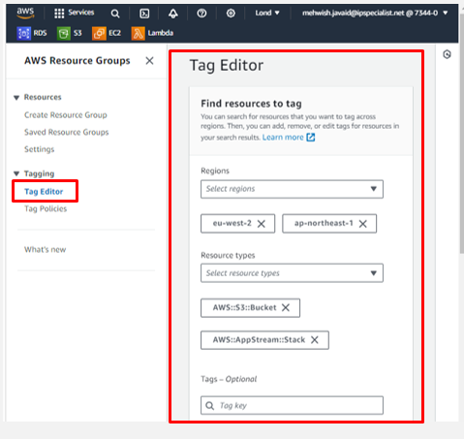

3. After applying tag, you can go to your active service and verify the tag.

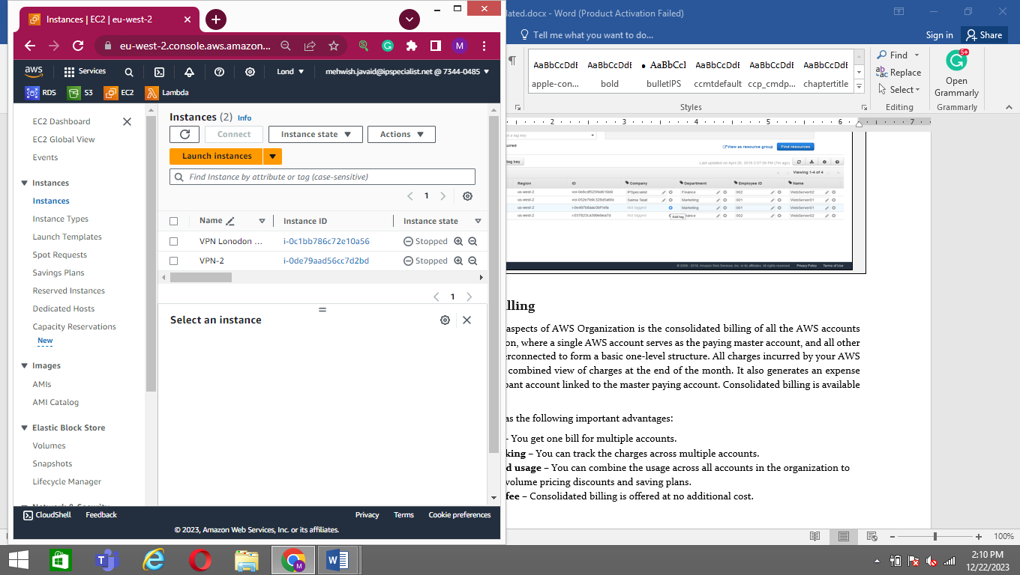

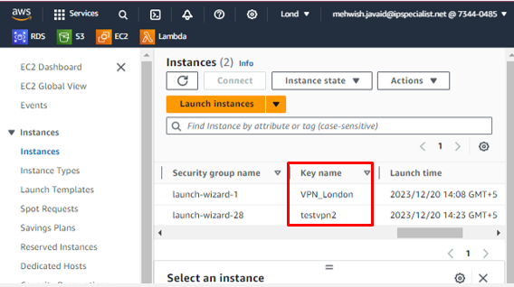

## Lab 6-04: AWS Simple Monthly Calculator

### Lab Prerequisites

* Familiarity with basic AWS Cloud Computing concepts and terminology
* An AWS account with an active subscription

### Service Introduction

The AWS Simple Monthly Calculator estimates your monthly bill depending on your unique configuration of resources. Whether running a single instance or dozens of individual services, you can organize your planned resources by service, and the Simple Monthly Calculator will calculate a monthly cost estimate for that configuration.

The calculator includes a cost breakdown for each service and a monthly total estimate. You can also use the calculator to estimate and break down costs for common cloud solutions.

### Case Study Enterprise Oil and Gas Contractor – Vector Energy

Background

Vector Energy is a specialty energy infrastructure contractor based in Houston, Texas, serving the oil, gas, refinery, petrochemical, and power industries. Engineering, procurement, construction, scheduled shutdowns, maintenance, facility development, and operations services are among the company's services. Vector Energy has constructed more than 114,000 miles of pipeline and employed more than 400 clients in 60 countries.

The oil and gas industry is cyclical. Vector Energy's capacity to adapt swiftly to new opportunities when there is high demand and scale back when demand is low is important to the company's success. The physical server infrastructure Vector Energy had in place was hampering the company’s marketplace agility.

The company’s IT environment combined collocation and on-premises servers in four primary data centers. Vector Energy also had dozens of offices—which sometimes had their own servers and networks—spread across the United States and Canada. The IT staff could not respond swiftly to new project requests in this physically distributed environment. It had trouble calculating the capacity required for new projects and quickly provisioning the appropriate number of servers. Without the ability to scale, the IT department would often oversubscribe, purchasing 20% extra capacity to avoid running out.

In addition, Vector Energy leadership wanted to focus on developing its core business, not its IT infrastructure. So, the company decided to move its business applications to the cloud to improve agility and focus more on developing its core business. AWS was the first choice for Vector Energy due to strong relationships and previous support experience.

Business Challenge

Vector Energy is planning to upgrade its infrastructure with AWS services. The business development team wants to know the estimated cost for requesting several services. They hired you as the cloud professional and asked you to provide a service cost calculated result for better decisions.

Proposed Solution

You propose a solution to the current challenge by using AWS Calculator. The Monthly Calculator is better for estimating the service cost before requesting it. As a Cloud Professional, you will easily do this task by selecting the service and adding the features. You will get an estimated cost after adding the required services.

Lab Diagram

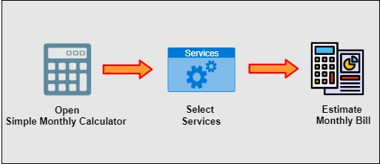

Figure 6-08: Lab Diagram

Implementation Steps

1. Launch the AWS Simple Monthly Calculator.
2. Select Amazon Services.
3. Estimate Monthly Bill.

### Solution

|  |
| --- |
| **Step 1: Launch the AWS Simple Monthly Calculator**   1. Open **AWS Simple Monthly Calculator** in your browser by using the URL **https://calculator.s3.amazonaws.com/index.html**.     **Step 2: Select Amazon Services**   1. Select the **Amazon Services** you need and add configuration details such as the **number of instances, instance types, billing options,** etc., depending on the type of service selected.     **Step 3: Estimate Monthly Bill**   1. Once you are finished selecting all the required resources and their configuration specifications, select the **Estimate of your monthly bill** tab at the top to see your estimated monthly cost calculation. |

## Lab 6-05: AWS Pricing Calculator

### Lab Prerequisites

* Familiarity with basic AWS Cloud Computing concepts and terminology
* An AWS account with an active subscription

### Service Introduction

The AWS Pricing Calculator allows you to analyze AWS services and calculate the cost of specific use cases on AWS. You can model your solutions before they are created, examine the price points and calculations that led to your estimate, and identify the instance types and contract terms that best suit your needs. This gives you the information you need to make an informed decision about whether or not to use AWS. You can budget for AWS prices and usage, or you can estimate the cost of launching a new set of instances and services.

The AWS Pricing Calculator is helpful for both new AWS customers and those who want to restructure or expand their AWS usage. AWS Pricing Calculator does not require any prior knowledge of the cloud or AWS.

### Case Study Enterprise Oil and Gas Contractor – Vector Energy

Business Challenge

Vector Energy is planning to move the on-premises infrastructure to the Cloud. The business development team wants to know the estimated cost for requesting Amazon Elastic Compute Cloud (Amazon EC2) and Amazon Simple Storage Service (S3). They hired you as a cloud professional and asked you to provide a service cost calculated result for making better decisions.

Proposed Solution

The Cloud professional proposes a solution to the current challenge by using the AWS Pricing Calculator. The Pricing Calculator is a better choice to estimate the service cost before requesting it. As a Cloud professional, you will do this task easily by simply selecting the service and adding the features. You can download the estimated report of the service cost in an Excel Sheet, which can be helpful in decision making.

Lab Diagram

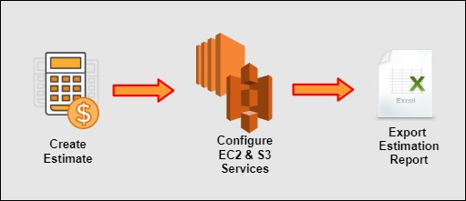

Figure 6-09: Lab Diagram

Implementation Steps

1. Create Estimate.
2. Configure Amazon EC2.
3. Configure Amazon S3.
4. Export Estimation Report.

Solution

|  |
| --- |
| **Step 1: Create Estimate**   1. Open a browser and go to the **AWS Pricing Calculator** <https://calculator.aws/> as shown below.      1. Click on **Create Estimate.**     **Step 2: Configure Amazon EC2**   1. Go to **Amazon EC2** and click on **Configure**.      1. **Configure EC2** as needed. 2. Enter **Description** as **AWS Pricing 1**. 3. Select the **Region**, **OS,** and **Instance type.** 4. Click on **Add to my estimate**.      1. A **Notification** will be displayed stating that **Successfully added Amazon EC2 estimate**.     **Step 3: Configure Amazon S3**   1. Click on **Add service** to add **Amazon** **S3**.      1. Go to **Amazon Simple Storage Service (S3)** and click on **Configure**.      1. **Configure Amazon Simple Storage Service (S3)** as needed. 2. Enter **Description** as **AWS Pricing 1**. 3. Select **Region** and choose **S3 Standard**.      1. Enter the values in the **S3 standard** as needed. 2. Then click on **Add to my estimate**.      1. A **Notification** will be displayed stating that **Successfully added Amazon Simple Storage Service (S3) estimate**. 2. You can see the **Estimate summary.**     **Step 4: Export Estimation Report**   1. You can **export** your estimation by clicking on **Export estimate**.      1. Now, click on **OK**.      1. You will get an **estimation report** in an **Excel** file. |